GLOBAL MAXIMUM POWER POINT TRACKING METHOD FOR PHOTOVOLTAIC ARRAYS UNDER PARTIAL SHADING CONDITIONS
ABSTRACT
The power–voltage characteristic of photovoltaic (PV) arrays displays multiple local maximum power points when all the modules do not receive uniform solar irradiance, i.e., under partial shading conditions (PSCs). Conventional maximum power point tracking (MPPT) methods are shown to be effective under uniform solar irradiance conditions. However, they may fail to track the global peak under PSCs. This paper proposes a new method for MPPT of PV arrays under both PSCs and uniform conditions. By analyzing the solar irradiance pattern and using the popular Hill Climbing method, the proposed method tracks all local maximum power points. The performance of the proposed method is evaluated through simulations in MATLAB/SIMULINK environment. Besides, the accuracy of the proposed method is proved using experimental results.

BLOCK DIAGRAM FOR PROPOSED SYSTEM
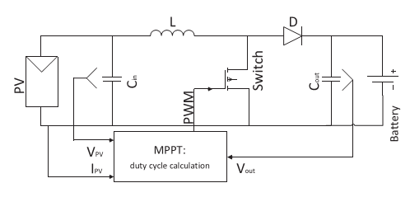
Fig. 1. Schematic of the system.
DESIGNG SOFTWARE AND TOOLS:
MAT LAB /SIMULATION Software and simu power systems tools are used. Mainly control system tools, power electronics and electrical elements tools are used.

